Lab 3-1 Saving Column Property Settings as System-Wide Defaults
Goals | To save Siebel Answers column settings as the system-wide defaults.
Scenario | As Administrator, you have privileges to save your column settings as the system-wide defaults. Anyone who uses these columns or columns of this data type in subsequent requests will use these column settings by default.
Time | 10 – 15 minutes
Environment | 
Instructions:
- If necessary, log in to Siebel Analytics as Administrator/Administrator.
- Select the SupplierSales subject area and create the following request:
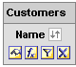
- Modify the value format settings for the Name column.
  - Click the Format Column button for the Name column.
  - Click the Value Format tab.
  - In the Font section, click the Color button.
  - In the Color Selector, type #000080 in the color field.
  - Click OK.
  - In the Cell section, click the Background Color button.
  - In the Color Selector, type # #99CCFF in the field.
  - Click OK.
  - In the Border section, in the Position drop-down list, select All.
  - Click the Border Color button.
  - In the Color Selector, type #000080 in the color field.
  - Click OK.
- Modify the column format settings for the Name column.
  - Click the Column Format tab.
  - Check Custom Headings.
  - In the Column Heading field, type Customer Name.
  - Click the Edit Format button next to the Column Heading field.
  - In the Family drop-down list, select Garamond.
  - In the Size field, type 16.
  - Click the Color button.
  - In the Color Selector, type #000080 in the color field.
  - Click OK.
  - In the Cell section, click the Background Color button.
  - In the Color Selector, type #99CCFF in the field.
  - Click OK.
  - In the Border section, in the Position drop-down list, select All.
  - Click the Border Color button.
  - In the Color Selector, type #000080 in the color field.
  - Click OK.
  - Click OK to close the Edit Format window.
- Save the column property settings for the Name column as the system-wide defaults.
  - Select the Value Format tab.
  - Select Save > as the system-wide default for ‘Customers.Name’. The Column Properties window closes.
  - Click Results to verify your work.
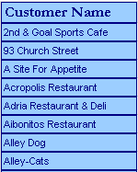
- Create a new request and verify that system-wide defaults are applied.
  - Click the Create a new request button .
  - Select the SupplerSales subject area.
  - Create the following request:
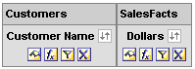
  - Click Results and verify your work:
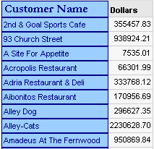
- Remove system-wide default settings from the Customer Name column.
  - Click the Criteria tab.
  - Click the Format Column button for the Customer Name column. The Column Properties dialog opens.
  - Click the Value Format tab. Notice that all value formatting is reset to Default.
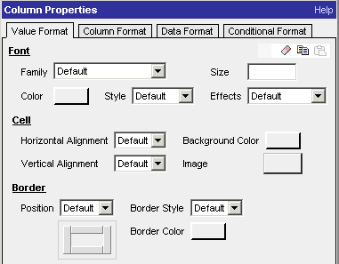
  - Click the Column Format tab.
  - Check Custom Headings.
  - In the Column Heading field, type Name.
  - Click the Edit Format button next to the Column Heading field. The Edit Format dialog opens. Notice that all formatting has been reset to Default.
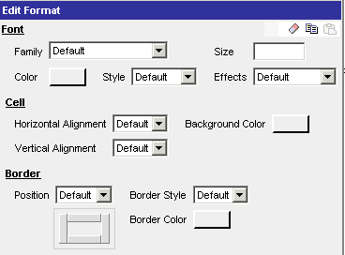
  - Click OK to close the Edit Format dialog.
  - Select Save > as the system-wide default for ‘Customers.Name’.
  - Click Results and check your work:
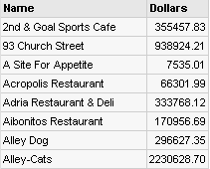
- Create a new request and verify that the system-wide defaults are removed.
  - Click the Create a new request button .
  - Select the SupplerSales subject area.
  - Create the following request:
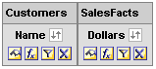
Notice that the Customers column changed from Customer Name back to Name.
- Click Results and verify your work:
- Leave the request open for the next lab.
Lab 3-2 Copying and Pasting Formatting Attributes
Goals | To copy and paste column formatting attributes and create a style template.
Scenario | You copy a range of cosmetic formatting attributes applied to objects and then paste them to an object of the same type. You then save a request with customized appearance as a style template for other requests and apply the style template to a new request.
Time | 10 – 15 minutes
Instructions:
- You should still have the following request open in the Results workspace from the previous lab. If not, create the request.
- Create and copy formatting attributes for the Name column cells.
  - Click the Edit View button for the Table view.
  - Click the Format Column button for the Name column. The Edit Column Format dialog opens.
  - Click the Value Format tab.
  - In the Font section, click the Color button.
  - In the Color Selector, type #000080 in the color field.
  - Click OK.
  - In the Cell section, click the Background Color button.
  - In the Color Selector, type # #99CCFF in the field.
  - Click OK.
  - In the Border section, in the Position drop-down list, select All.
  - Click the Border Color button.
  - In the Color Selector, type #000080 in the color field.
  - Click OK.
  - Click the Copy Cell Format button .
- Paste the cell format in the Column Format tab.
  - Click the Column Format tab.
  - Click the Edit Format button next to the Column Heading field. The Edit Format dialog opens.
  - Click the Paste Cell Format button . Notice that the cell format attributes change:
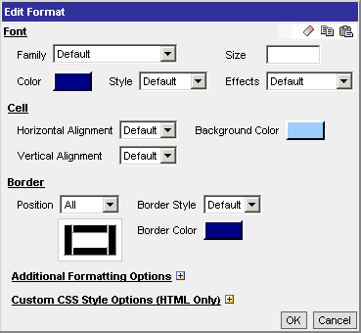
  - Click OK to close the Edit Format dialog.
  - Click OK to close the Edit Column Format dialog.
  - Check your results. Notice that both the column heading and column values have the same formatting:
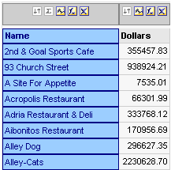
- Apply the cell format to the Dollars column.
  - Select the Format Column button for the Dollars column.
  - Click the Value Format tab.
  - Click the Paste Cell Format button . Notice that the cell format attributes change:
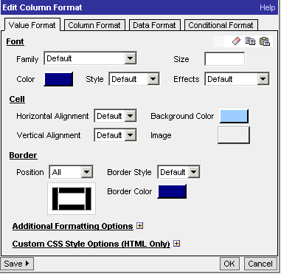
  - Click the Column Format tab.
  - Click the Edit Format button next to the Column Heading field. The Edit Format dialog opens.
  - Click the Paste Cell Format button . Notice that the cell format attributes change:
  - Click OK to close the Edit Format dialog.
  - Click OK to close the Edit Column Format dialog.
  - Check your results:
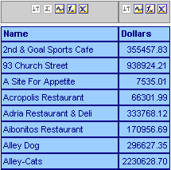
  - Save the request as Style Template.
- Clear the formatting for the Name column.
  - Click the Format Column button for the Name column. The Edit Column Format dialog opens.
  - Click the Value Format tab.
  - Click the Clear Cell Format button to restore cell format defaults.
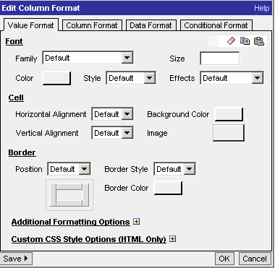
  - Click the Column Format tab.
  - Click the Edit Format button next to the Column Heading field. The Edit Format dialog opens.
  - Click the Clear Cell Format button to restore cell format defaults.
  - Click OK to close the Edit Format dialog.
  - Click OK to close the Edit Column Format dialog.
  - Repeat the steps to clear the cell formatting for the Dollars column.
  - Check your work:
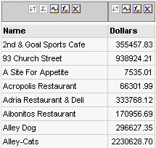
- Use a saved request as a style template.
  - Create a new request:
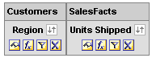
  - Click Results:
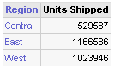
  - Click the Import View Formatting buttonnear the top of the workspace.
  - In the Choose Request dialog box, select the Style Template request and click OK.
  - Check your work:
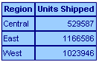
- Leave Siebel Answers open for the next lab.
Lab 3-3 Using Custom Date Format Strings
Goals | To apply custom date format strings to columns in a request.
Scenario | You apply some general custom format strings to the date column in a request to view date data in different formats.
Time | 10 – 15 minutes
Instructions:
- Create the following request and associated filters:
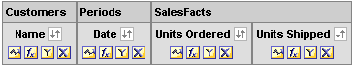
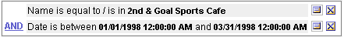
- Click Results:
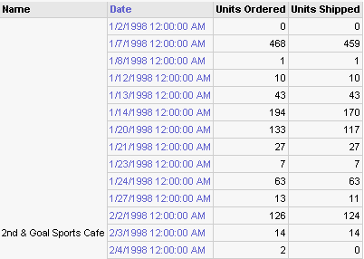
- Apply a custom format string for the Date column.
  - Click the Edit View button for the Table view.
  - Click the Format Column button for the Date column. The Edit Column Format dialog opens.
  - Click the Data Format tab.
  - Note the default date format is set to Locale Short Date/Time: 5/8/2003 7:34:57 AM in the Date Format field and is displayed as [FMT:timeStampShort] in the Custom Date Format field.
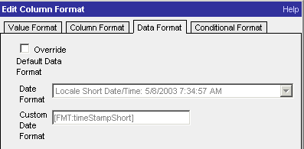
  - Check the Override Default Data Format option.
  - In the Date Format field, select Custom from the drop-down list.
  - In the Custom Date Format field, type [FMT:dateShort]. This formats the date in the Siebel short date format according to the user’s locale.
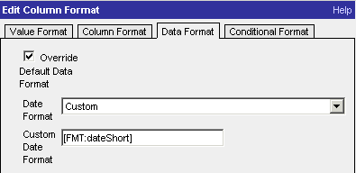
Note: You must type the custom format string into the Custom Date Format field. Custom format strings are not available for selection from a drop-down list.
  - Click OK to close the Edit Column Format dialog box.
  - Check your results:
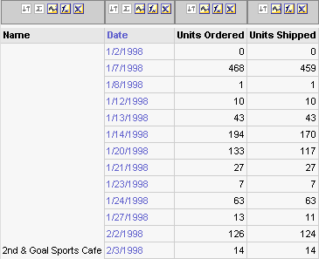
  - Repeat the steps to apply the [FMT:dateLong] format and check your results:
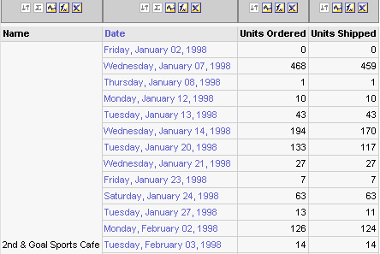
  - Repeat the steps to apply the [FMT:dateODBC] format and check your results:
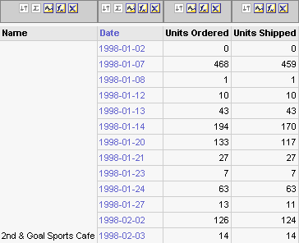
- Restore the default date format.
  - Click the Format Column button for the Date column. The Edit Column Format dialog opens.
  - Click the Data Format tab.
  - In the Date Format field, select Locale Short Date/Time: 5/8/2003 7:34:57 AM from the drop-down list.
  - Uncheck the Override Default Data Format option.
  - Click OK to close the Edit Column Format dialog box.
  - Check your results:
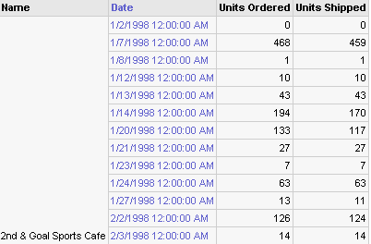
- Leave Siebel Answers open for the next lab.

